**The Agony of Attrition[1]**

"You know, we have spent a lot of time for this project. This is our first entry into telecom sector. You should make sure that nothing goes wrong on this. Especially no time overruns!" warned Madhu Agrawal. "I know, I have been part of the original team which negotiated with the Anglo-French. My only worry is the danger of attrition. As long as my team members don't quit, I have no problem. We can deliver on time. I suggest, you give me couple of extra team members so that we don't have to worry about attrition" said Sandy Goel.

NS Software Systems (N3S) just signed a contract with the Anglo-French Telecom AB for a new project. This is their first foray into the telecom sector. The company decided that the costs are not a concern, but the project has to be delivered on time. Madhumita Agrawal, the Senior Asst. Vice President (HR) is discussing with Sandarsh Goel with an offer to help him select the team for the project. Sandy had been identified to spearhead the project. As is typical in the industry, N3S has to live with attrition of the employees. They are expecting an attrition rate of 20 percent in the current year. One of Madhu's immediate goals is to try and reduce this to 15 percent. She is working on a package of new incentives.

"We planned on a team of three, not including you. There is no way you can get anymore. Everybody is short staffed in this industry and so are we in all our projects. But, I can let you choose whom ever you want and I am willing to pull them out from their current assignments" offered Madhu to Sandy.

Sandy met Madhu two days later. The three people he suggested are Dinesh, Lakshmi and Partho. He also made some quick calculations that if only one member of his team quits, the project will be delayed by a week only. Assuming that two members quit, the delay will be 3 weeks and if all of them quit, it will be 6 weeks. "I am assuming that you will give me a replacement immediately. Otherwise the time overruns will be much much longer" he cautioned Madhu. "I am also assuming that the replacements won't leave and these guys don't influence each other", he added. "I can make sure of the first part and as for the second part, I am certain that these guys will not be influenced by others; that has been our experience. Also, with the new incentives coming up, our attrition rate will be down to 15 percent. As a matter of fact, I am willing to put the probability of this happening (*she means the attrition rate coming down to 15 percent*) at 60 percent. Of course, the alternative is to live with 20 percent attrition", said Madhu.

Sandy started thinking-can he quantify the risk now, and calculate the possible delay, if any?

Dinesh Lakshmi and Partho: They are taking decision independently. This is statistically independent events.

So P(LStays|DLeaves) or P(LS|Dstays) = 0.8 always. No matter Lakshmi’s decision is not based on Dinesh

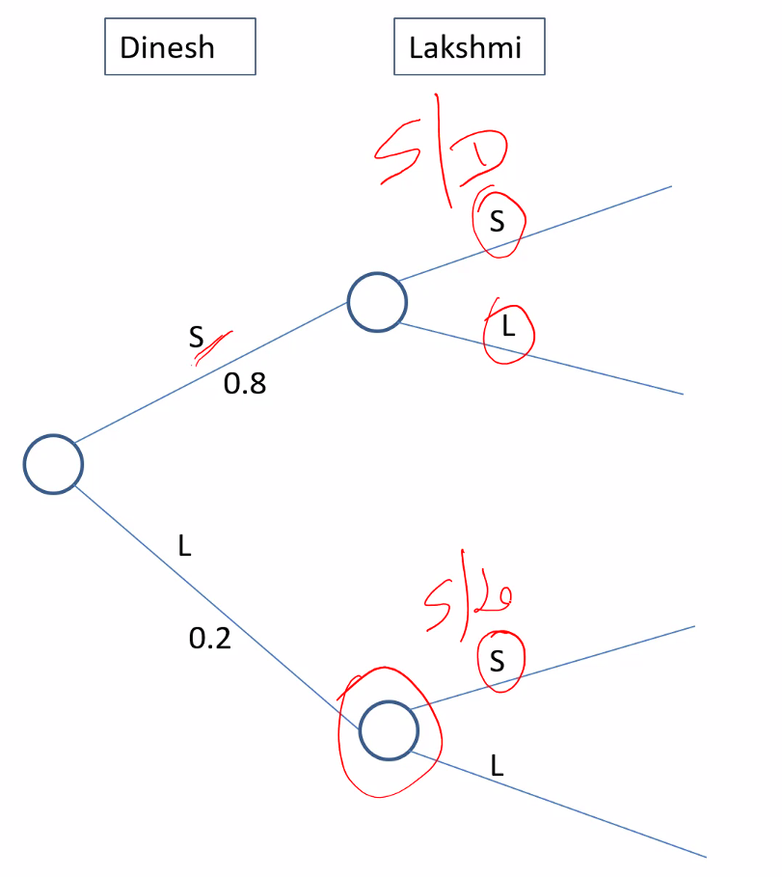

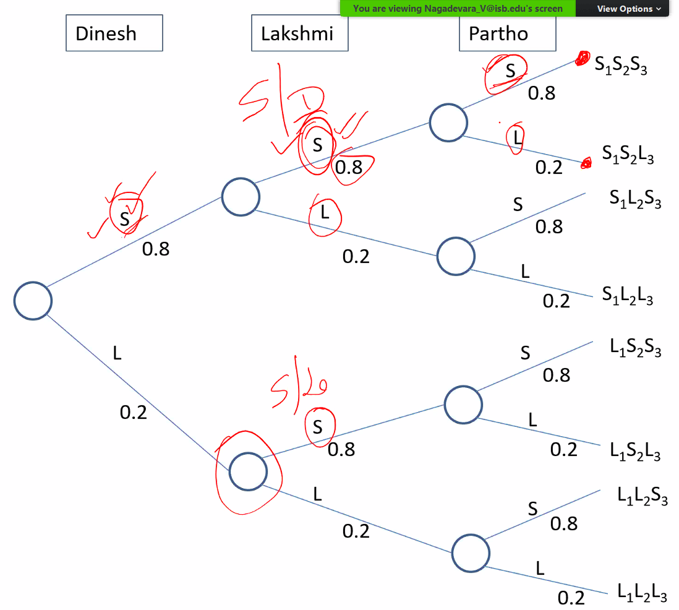

1 = Dinesh, 2 = Lakshmi 3 = Partho

S1S2S3 = 0.8*0.8*0.8 = 0.512

S1S2L3 =

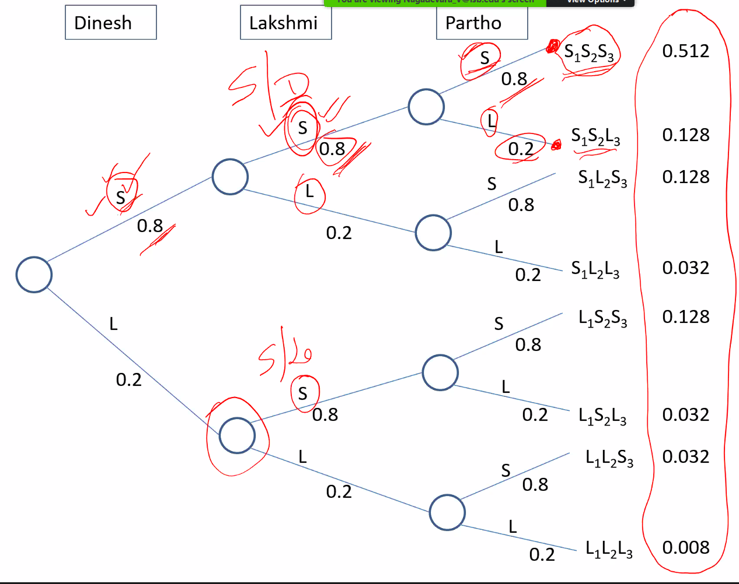

These numbers can be summarized into 4 possibilities:

1. 0 people leave: 0.512
2. 1 people leaves: S1S2L3 + S1L2S3 + L1S2S3
3. 2 people leaves: S1L2L3 + L1S2L3 + L1L2S3+
4. all 3 leaves: 0.008

This gives us a Probability Mass Function

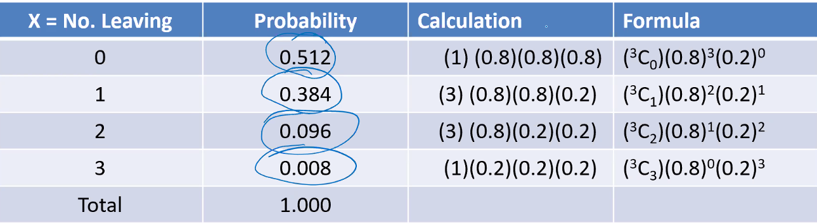

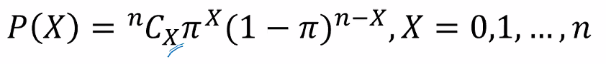

Leaving the company is a success is considered here.

 for binomial distribution.

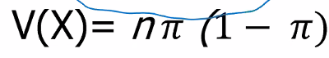 -- Remember this

So if we are seeing in a report before and after format:

|  |  |  |  |  |  |
| --- | --- | --- | --- | --- | --- |
| **Agony of attrition initial condition** | | | | | |
| **number of trials =** | **3** | **Probability of leaving i.e. success =** | **0.2** | **Penalty per week $ =** | **100000** |
|  |  |  |  |  |  |
| **X = number of persons leaving** | **P(X)** | **Delay in weeks** | **Penalty** |  |  |
| 0 | 0.512 | 0 |  |  |  |
| 1 | 0.384 | 1 |  |  |  |
| 2 | 0.096 | 3 |  |  |  |
| 3 | 0.008 | 6 |  |  |  |
| **Total** | 1 |  |  |  |  |
| **Expected value =** | 0.6 | 0.72 | 72000 |  |  |

|  |  |  |  |  |  |
| --- | --- | --- | --- | --- | --- |
| **agony of attrition final condition. This is proposed by the HR that the probability of leaving the company will come down by this that techniques** | | | | | |
| **number of trials =** | **3** | **Probability of leaving i.e. success =** | **0.15** | **Penalty per week $ =** | **100000** |
|  |  |  |  |  |  |
| **X = number of persons leaving** | **P(X)** | **Delay in weeks** | **Penalty** |  |  |
| 0 | 0.614125 | 0 |  |  |  |
| 1 | 0.325125 | 1 |  |  |  |
| 2 | 0.057375 | 3 |  |  |  |
| 3 | 0.003375 | 6 |  |  |  |
| **Total** | 1 |  |  |  |  |
| **Expected value =** | 0.45 | 0.5175 | 51750 |  |  |

Now the HR has given this assurance of bringing down the probability to 15% by as chance of 60% i.e. there is still a 40% chance that all the measures taken by HR might not bring the attrition level down.

|  |  |  |
| --- | --- | --- |
| **Measure** | **E(V)** | **Probability** |
| **Previous penalty remains same as attrition level has not gone down** | 72000 | 0.4 |
| **Penalty decreases as the attrition level gone down** | 51750 | 0.6 |
| **Actual Expected value of penalty** | 59850 |  |
| **Difference in penalty expected value** | 12150 |  |

1. V Nagadevara, Indian Institute of Management Bangalore